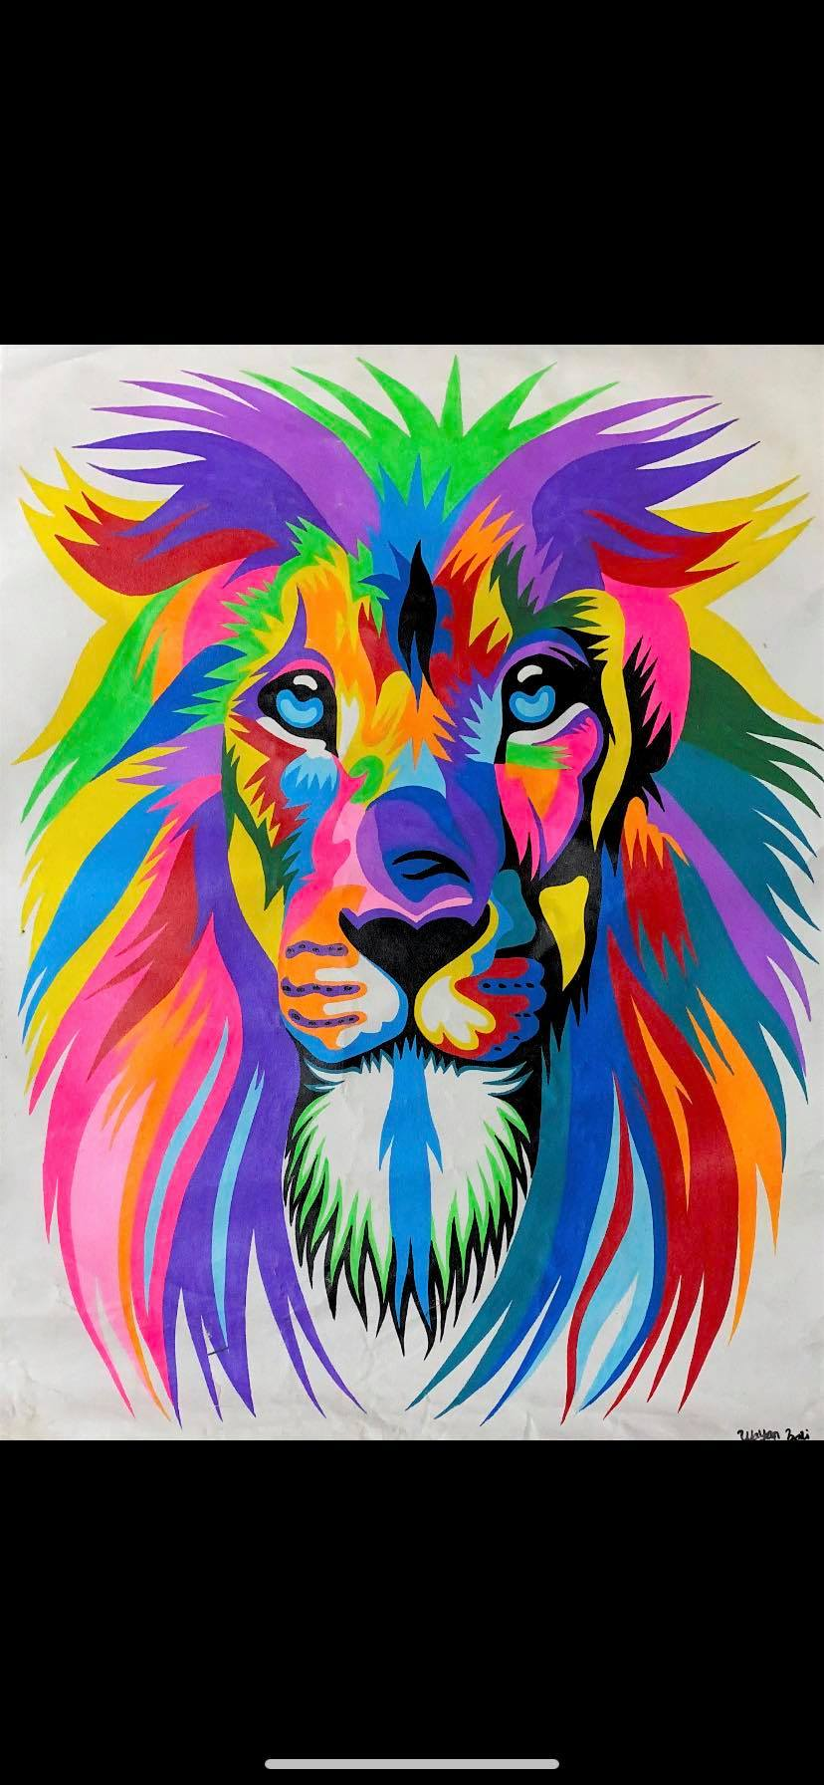

**Raffle - $2.00 Per Ticket**

**Unframed Canvas Artwork 78cm x 58.5cm**